**Quiz** 6: Urinary System and Review of Pulse, BP and the Lymphatic System

Anatomy and Physiology II Lab, Summer C 2014

1) The process by which plasma is forced through Bowman's capsule is called ____________.

2) During the process of ____________, certain substances are removed from the filtrate in parts of the kidney and returned to the interstitial space (and eventually, the blood).

3) TRUE/FALSE: One step of **urinalysis** involves examination of urine sediment under a microscope.

4) The basic microscopic unit of the kidney is the

a. ureter

b. urethra

c. urinary bladder

d. nephron

5) Which of the following substances are reabsorbed in the kidney?

a. water

b. electrolytes

c. none of the above

d. water and electrolytes

6) TRUE/FALSE: Renal capillaries do not closely associate with kidney tubules.

------------------------------------------------------------------------------------------------------------------------------------------

REVIEW: Pulse, BP and the Lymphatic System (EXERCISES 4 & 5)

7) During the "filling phase" of the cardiac cycle, SYSTOLIC/DIASTOLIC (choose one) pressure is measured.

8) Which of the following lists the lymphatic vessels in order from smallest to largest?

a. ducts, capillaries, vessels, trunks

b. capillaries, vessels, trunks, ducts

c. capillaries, trunks, vessels, ducts

d. vessels, capillaries, trunks, ducts

9) The spleen is responsible for filtering LYMPH/BLOOD (choose one).

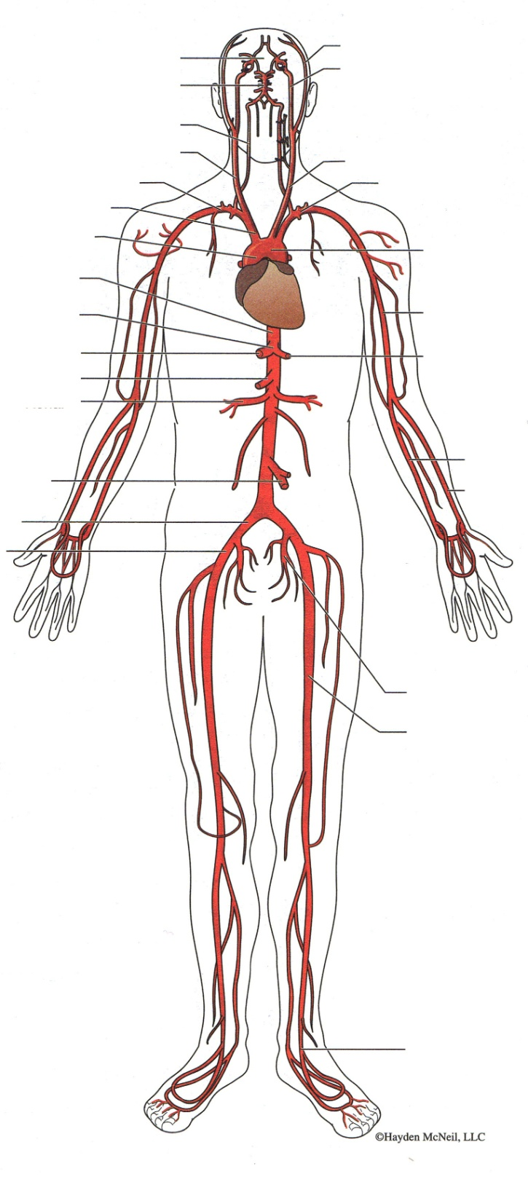

10) Please label the 4 structures indicated with heavy arrows below.

A.

B.

C.

D.

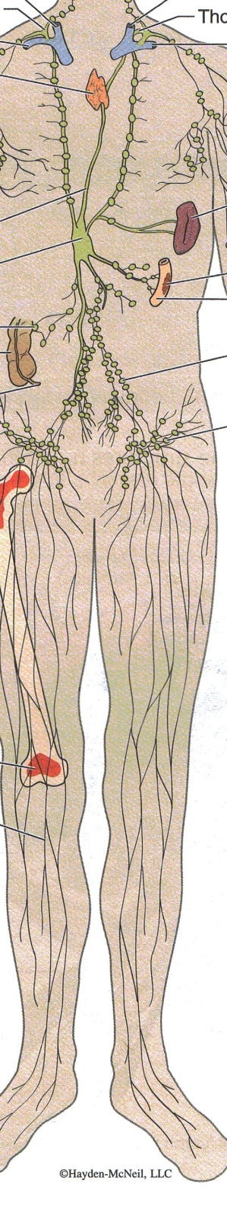



B.

A.

12a. Please label the structure indicated with a heavy arrow below.

12b. Within what tissue is it located?

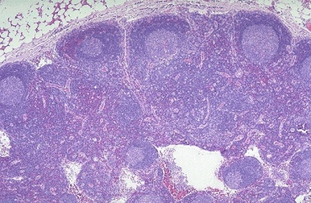

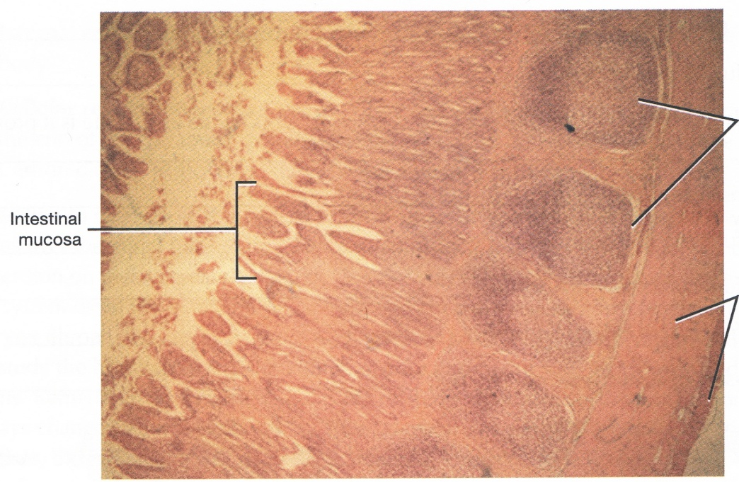

13) Be sure to observe the intestinal mucosa labeled in the image above. What are the structures encircled in black?