General Guidelines for Wolbachia PowerPoint Presentation
Deadlines:
- Final presentation: Week of 4/20/15
  - Final draft submitted to D2L DropBox by beginning of lab meeting during week of 4/20/15.

General Guidelines
- Work in pairs.
- Presentation 10 minutes total (~ 8 minute presentation; ~ 2 minutes questions)
- Both partners must contribute to generating all aspects of the presentation, Slides should be marked to indicate student contribution for each slide. Both partners must orally present different components of the project. Failure to do so will result in a grade reduction.
- Both samples must be addressed in your presentation.
- Presentation must include the following components (each component described below) although the order may vary:
Outline
Introduction
Methodology/Experimental design
Results
Conclusions/Future work
References

Specific Content
The following sections should be included in your presentation but may be presented in whatever order you feel tells your story best. Pay attention to the amount of text included on each slide. Use the notes section below the slide (in PowerPoint) to include any talking points or items that you plan to discuss when you give your presentation. This will allow your instructor to see what items will be addressed even if they are not written on your slide.

- Introduction to the project
  - Introduce the Wolbachia project and why Armstrong students are participating

- Description of your sample
  - Describe the Order of your sample
    - If you know what specific type of insect(s) you have (more specific than Order), you can address these for that insect rather than the Order. However you must still state the name of the Order that your insect belongs to. If you don’t know what specific insect you have, stick to describing the Order.
    - Include documentation of the identification of your specific insects: labeled drawings and possibly photographs of your sample.
    - Any additional photographs taken off the web should have the website cited underneath the photograph (can make the link very small).
  - Clearly describe your hypothesis and the scientific data that it was based on.
    - Remember to reference peer-reviewed scientific articles.
    - Briefly explain what was discovered in these articles and how they support your hypothesis.
    - Include any information about how Wolbachia is spread within your Order (if known).

- Methodology/Experimental design
  - The presentation should contain one or more slides that outline and describe the experiment you conducted on your sample. You may use a flow chart, bullet points and/or pictures to describe the relevant steps and techniques you used in your experiment.
    - Hint: This slide/these slides should NOT read like the lab manual – be careful to include only relevant information. For example, you may want to include that the DNA extraction procedure consisted of three general stages (e.g., lysis, wash, elution), but you should NOT list every single step that you performed (e.g., Added 500μL wash buffer…)
  - At some point in your presentation, you should address the genes detected in PCR as well as explicitly stating what your + control, - control and no template controls were. You may choose to express these verbally rather than in text on your slide.

- Results
  - Describe the processes of insect collection and identification.
  - Include the concentration and purity of DNA you extracted (this is data, after all!) Hint: A table is a nice way to organize this type of data.
  - Include a labeled photograph of your agarose gel results.
    - Include key facts about the gel (i.e. % agarose, voltage)
    - Label the lanes and the size of the products
    - Describe controls and the results.
  - Include the results of sequencing and phylogenetic analysis for your sample if it was infected with Wolbachia. If your sample was not infected with Wolbachia, then you should still present your results from the phylogenetic analysis of a sample from the same Order as your sample.
  - Discuss anything that did not go as expected (controls not work? DNA extraction didn’t go well, gel did not go well?) This happens, but you must be prepared to present what you have and explain what factors might have contributed to the problems.

- Conclusions/Future work
  - Did your results support your hypotheses?
  - Discuss the relevance of your conclusions.
  - What future experiments would you recommend researchers perform to follow up on your work?

- Citations
  - The 2 research articles whose findings you incorporate into your presentation MUST be cited in the last slide of your presentation using the format shown below:
  - Any images taken from the web must include the website underneath the image as well as the date accessed.

Grading:
- Presentation: The oral presentation and final draft together are worth two-thirds of the total presentation grade.
Tips for the Appearance of the PowerPoint File and for the Oral Presentation
- A good PowerPoint presentation is clear and concise. The presentation should tell your Wolbachia story in an organized manner that is easily followed by your audience.
- Remember who your audience is – these are your peers that are familiar with the Wolbachia project. However, a freshman student who is not familiar with the Wolbachia project should also understand your presentation.
- Good PowerPoint slides contain mostly images and limit the number of words to those that are critical for audience understanding. In other words, slides should NOT contain too much text. For example, look at the two slides below.
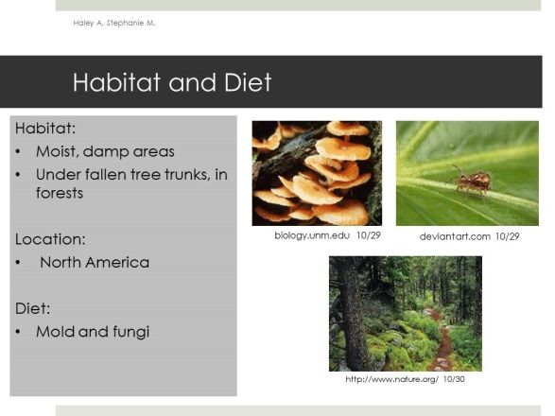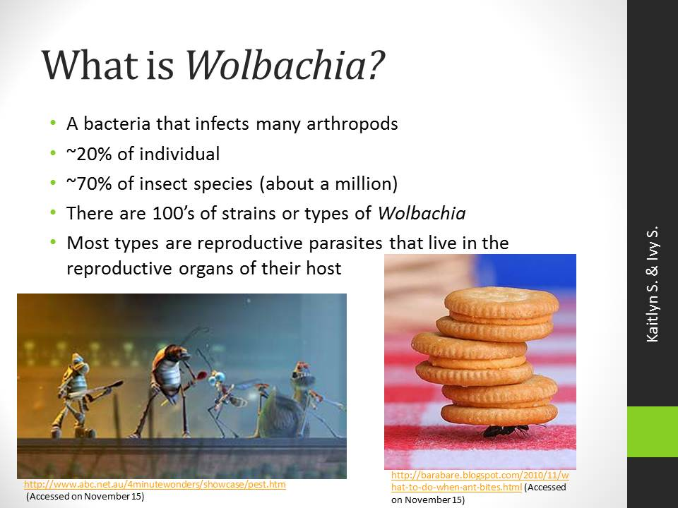
- The text that is included should be in a font that is readable, i.e., one that is not too small.
- Do NOT use a distracting theme or animations.
- Do NOT stretch images to distortion.
- DO practice to be sure that the presentation is in within the acceptable time limit. (Hints: When you practice, speak out loud – you think a lot faster than you speak! Also, plan to reserve a room at the Learning Commons; these rooms have projectors that can be connected to a laptop, so you and your partner can practice with projected slides).
- During your presentation, do NOT simply read the content of the slides. This is boring to the audience and it conveys the impression that you do not understand the content since you cannot explain it in your own words. Think about what you want to say ahead of time (writing down notes/an outline if necessary) then PRACTICE explaining your assigned slides. The more you practice (again, OUT LOUD), the less nervous you will be.
- DO make your introduction thorough and thoughtful but do NOT spend 80% of your presentation on your introduction, leaving little time for you to describe YOUR experiment and its results – this is after all, the most important part of your presentation.
- DO speak in a loud enough voice that people in the back of the room can hear you.
- DO speak at an appropriate pace – not too fast or too slowly.
- DO (as much as possible), make eye contact with your audience
- DO inject humor and enthusiasm, when appropriate but do NOT be unprofessional during your presentation (i.e., giggle, mumble).

